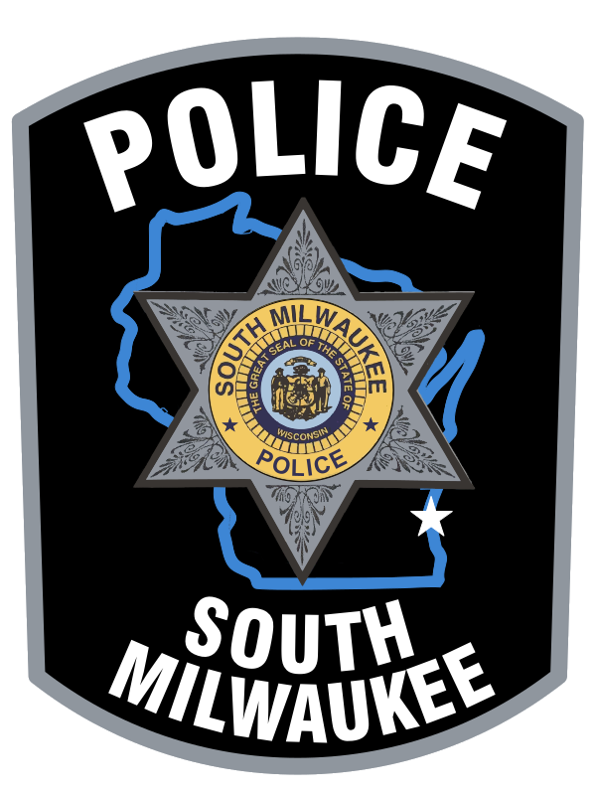




D.A.R.E.
South Milwaukee
Police Department
24th Annual
Golf Outing
The South Milwaukee DARE program currently consists of Officers Adam Harnen and Jakob Horsley who teach DARE to every public and parochial 5th grade student in South Milwaukee on an annual basis.
DARE stands for Drug Abuse Resis-
tance Education. It is a 10-week program designed to educate young people on how to develop and maintain healthy lifestyles in their communities. With your support, the DARE program will reach hundreds of students in South Milwaukee over the next several years. We will teach each child the importance of staying drug free and avoiding violence. Your support is greatly appreciated. All money raised from this outing will be used to buy books and other supplies needed for teaching the DARE program.

The South Milwaukee Police Department and DARE students of
South Milwaukee thank you!
Please join us for a day of fun on
Monday, July 20th, 2026 at 8 am @ Grant Park Golf Course (100 Hawthorne Avenue, South Milwaukee, WI). We look forward to seeing you!!!!

INFORMATION ABOUT DARE

DARE is the largest, most recognized
anti-drug and violence program in the world.
DARE is taught by specially trained po- lice oﬃcers. These oﬃcers go into the classroom once a week to teach a one-hour lesson on various topics. These topics include: learning the harmful eﬀects of drugs, dealing with peer pressure, strategies in resisting drug oﬀers, beating stress, self-esteem building, avoiding violence, and how to get involved in positive activities.

During the program, oﬃcers form friendships and create impressions that will last a lifetime. DARE is a program that lets children get to know oﬃcers personally, in a positive manner, that helps discourage the false perceptions of police oﬃcers.

Upon completion of the DARE program, there is a graduation ceremony where the oﬃcer, chief, and mayor get a chance to speak to the graduates and their parents about continuing a healthy lifestyle which the DARE message emphasizes.

Help Us Get the DARE Message to Thousands of South Milwaukee’s Children, Today and Tomorrow!






You are cordially invited to the annual DARE golf outing. This year’s fundraiser is hosted by the South Milwaukee Police Department.
The outing includes the chance to win A vehicle for a hole-in-one (along with other hole contests), lunch at the South Milwaukee Bucyrus Club, and an awards ceremony and raﬄe after the meal.

Please join us for a day of fun at Grant Park Golf Course in South Milwaukee, WI. A shotgun start will take place at 8:00 AM. Space is limited to 144 golfers. Deadline for signup is 07/13/2026.
A company or organization, or any individual, can also sponsor a hole on the course. A $600 donation provides a sole sponsorship sign at a hole on the course and a foursome for the golf outing. A $100 donation allows a shared sponsorship of a hole on the course.

For more information, please call:
Officer Adam Harnen or Jakob Horsley at 414.768.8060.

REGISTRATION FORM
24th Annual DARE Golf Outing Monday, July 20th, 2026 Shotgun Start at 8:00 AM
Registration @ 7:00 AM

Golfer’s Name and Address
1.

2.

3.

4.

An organization or company can sponsor a foursome. Single players and twosomes will be paired with another group to complete foursomes.

Please Mail Registration Form and Check to:
SMPD DARE
2424 15th Ave
South Milwaukee, WI 53172
To Resist Drugs and Violence:
24th Annual Golf Outing Fundraiser Organized by
South Milwaukee Police Department’s DARE Program
Monday, July 20th, 2026 Start time is at 8:00 AM at the Grant Park Golf Course

4 Person Scramble Format
$100.00 per person

Includes: 18 holes of golf, cart, sleeve of balls, tees, lunch, on-course
Contests and raffle prizes.

